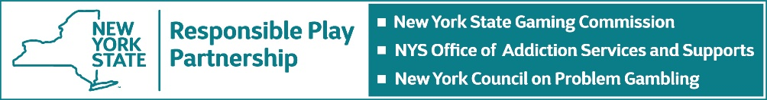

For immediate release,
March 2, 2021

NEW YORK’S RESPONSIBLE PLAY PARTNERSHIP BLANKETS STATE WITH EVENTS AND INFORMATION ABOUT PROBLEM GAMBLING PREVENTION, TREATMENT AND RECOVERY

Plans coincide with National Problem Gambling Awareness Month sponsored by the National Council on Problem Gambling

Members of New York’s Responsible Play Partnership (RPP) which include the New York State Gaming Commission, the New York State Office of Addiction Services and Supports (OASAS) and the New York Council on Problem Gambling (NYCPG) have announced a month-long schedule of public events, professional trainings and general educational programming in support of National Problem Gambling Awareness Month (PGAM) in March. The initiatives highlight the RPP’s coordinated efforts to blanket the State with information about problem gambling and the availability of related prevention, treatment and recovery services.
Commission Executive Director Robert Williams said, “We support the National Council on Problem Gambling’s efforts to focus attention on problem gambling which at its core involves a loss of control over one’s gambling. The Commission’s goal for PGAM and beyond is to actively promote the benefits of Responsible Play which underscore the importance of setting a budget and time limit for play, prioritizing family and friends over gambling, and exploring other forms of entertainment, among other things. We will also continue to infuse Responsible Gaming elements into the production and marketing of our products and encourage our licensees to do the same.”
OASAS Commissioner Arlene González Sánchez said, “Problem gambling affects thousands in New York State, and can have negative impacts on people regardless of their background, age, or any other factors. OASAS is committed to establishing necessary supports for those impacted, as well as their families, and Problem Gambling Awareness Month is an opportunity to highlight the prevention, treatment, and recovery services that are available. This important observance will help us further raise awareness of this important issue, and the great work that is happening here in New York State.”
NYCPG Executive Director Jim Maney said, “Now more than ever it is imperative that we provide for those who are struggling, those who cannot gamble responsibly and to address problem gambling at all levels statewide, regionally, and locally. We are pleased to have an unprecedented amount of manpower to do just that through seven Problem Gambling Resource Centers (PGRCs). The services provided by the PGRC staff statewide are focused on just one thing - connecting those in need to information and services. We are here to help.”
Using the tagline #AwarenessPlusAction, members of the RPP will work collaboratively to deliver a mix of webinars, screenings, training days, traditional and social media campaigns, and other awareness initiatives to focus public attention on the issue and in the words of National Council Executive Director Keith Whyte, “to let people know that hope and help exist.”
The RPP will debut its new Public Service campaign designed to promote Responsible Play as a practical safeguard against disordered gambling. The multi-faceted initiative features live-read messages showcasing the State’s confidential 1-877-8-HOPENY addictions referral hotline during televised New York Lottery drawings, printed on Lottery scratch-off tickets and promoted on the Lottery’s retail displays, terminals and website; digital and print displays within commercial casinos, video lottery gaming facilities, horse racing tracks and off-track betting offices; social media posts on Facebook, Twitter, Instagram and other platforms; TV and radio public service announcements; and complementary posters displayed at select Welcome Centers along the New York State Thruway.
In addition, the NYCPG in cooperation with OASAS will present a weekly webinar featuring subject matter experts in the fields of Prevention, Screening/Intervention, Treatment, and Recovery. The pair will also actively promote regional events and programming at the seven Problem Gambling Resource Centers (PGRC) that now service at-risk populations in New York City and Long Island as well as the Mid-Hudson Valley, Northeast, Central, Finger Lakes and Western areas of the State. More information on the webinars, speakers and other supporting events is available at https://nyproblemgambling.org/pgam/
To bring the PGAM campaign full circle, members of the RPP will once again invite Commission staff as well as employees within the prevention, treatment and recovery communities to participate in National Gambling Disorder Screening Day. The one-day online event held annually on the second Tuesday of March helps identify individuals who might have gambling disorder and should seek further assessment.

# # #

